**Program No: 01 Date:16-08-2022**

**Aim**:Develop android application to implement button click using toast.

**Program Code:**

**activity.xml**

*<?*xml version="1.0" encoding="utf-8"*?>*<androidx.constraintlayout.widget.ConstraintLayout xmlns:android="http://schemas.android.com/apk/res/android"  
 xmlns:app="http://schemas.android.com/apk/res-auto"  
 xmlns:tools="http://schemas.android.com/tools"  
 android:layout_width="match_parent"  
 android:layout_height="match_parent"  
 tools:context=".MainActivity">  
  
 <TextView  
 android:layout_width="wrap_content"  
 android:layout_height="wrap_content"  
 android:text="Hello World!"  
 app:layout_constraintBottom_toBottomOf="parent"  
 app:layout_constraintLeft_toLeftOf="parent"  
 app:layout_constraintRight_toRightOf="parent"  
 app:layout_constraintTop_toTopOf="parent" />  
 <Button  
 android:layout_width="wrap_content"  
 android:layout_height="wrap_content"  
 android:id="@+id/btn1"  
 android:textColor="@color/black"  
 android:background="@color/cardview_shadow_end_color"  
 android:text="Button click" />

**mainactivity.java**

package com.example.myapplication;  
  
import androidx.appcompat.app.AppCompatActivity;  
  
import android.os.Bundle;  
import android.view.View;  
import android.widget.Button;  
import android.widget.Toast;  
  
public class MainActivity extends AppCompatActivity {  
  
 @Override  
 protected void onCreate(Bundle savedInstanceState) {  
 super.onCreate(savedInstanceState);  
 setContentView(R.layout.*activity_main*);  
 Button b=findViewById(R.id.*btn1*);  
 b.setOnClickListener(new View.OnClickListener() {  
 @Override  
 public void onClick(View view) {  
 Toast.*makeText*(getApplicationContext(),"buttonclicked",Toast.*LENGTH_LONG*).show();  
 }  
 });  
 }  
  
 }

**OUTPUT**

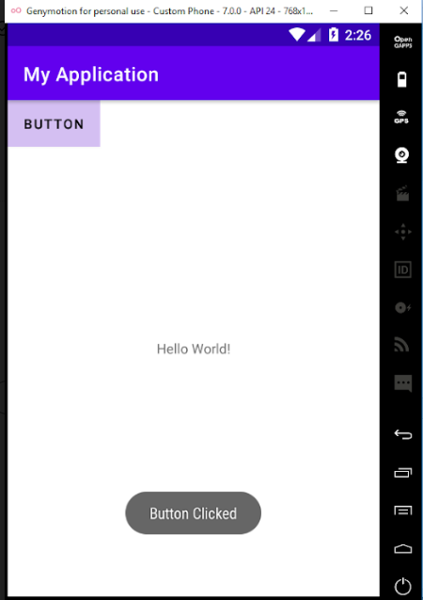

**Program No: 02 Date:19-08-2022**

**Aim**: Design a login form with Username and Password using linear layout and toast valid credentials.

**Program Code:**

**activity.xml**

*<?*xml version="1.0" encoding="utf-8"*?>*<LinearLayout  
 xmlns:android="http://schemas.android.com/apk/res/android"  
 xmlns:app="http://schemas.android.com/apk/res-auto"  
 xmlns:tools="http://schemas.android.com/tools"  
 android:layout_width="match_parent"  
 android:layout_height="match_parent"  
 tools:context=".MainActivity"  
 android:orientation="vertical">  
  
 <TextView  
 android:layout_width="wrap_content"  
 android:layout_height="wrap_content"  
 android:text="Login"  
 android:textSize="@dimen/cardview_default_radius"/>  
  
 <EditText  
 android:layout_width="match_parent"  
 android:layout_height="wrap_content"  
 android:hint="username"  
 android:id="@+id/et1"  
 />  
 <EditText  
 android:layout_width="match_parent"  
 android:layout_height="wrap_content"  
 android:hint="password"  
 android:id="@+id/et2"  
 android:layout_marginTop="10dp"  
 android:inputType="textPassword"  
 />  
 <Button  
 android:layout_width="wrap_content"  
 android:layout_height="wrap_content"  
 android:text="Login"  
 android:id="@+id/btn"  
 android:layout_marginLeft="140dp"  
 />

</LinearLayout>

**Mainactivity.java**

package com.example.pgm2;  
import androidx.appcompat.app.AppCompatActivity;  
  
import android.os.Bundle;  
import android.view.View;  
import android.widget.Button;  
import android.widget.EditText;  
import android.widget.Toast;  
  
public class MainActivity extends AppCompatActivity {  
  
 @Override  
 protected void onCreate(Bundle savedInstanceState) {  
 super.onCreate(savedInstanceState);  
 setContentView(R.layout.*activity_main*);  
 EditText et1=findViewById(R.id.*et1*);  
 EditText et2=findViewById(R.id.*et2*);  
 Button button=findViewById(R.id.*btn*);  
button.setOnClickListener(new View.OnClickListener() { @Override  
 public void onClick(View view) {  
 validate(et1.getText().toString(),et2.getText().toString());  
 }  
 private void validate(String us,String pw)  
 {  
 if(us.equals("admin")&&pw.equals("1234"))  
 {  
 Toast.*makeText*(getApplicationContext(),"Login successfull",Toast.*LENGTH_LONG*).show();  
 }  
 else  
 {  
 Toast.*makeText*(getApplicationContext(),"Unsuccessfull login",Toast.*LENGTH_LONG*).show();  
 }  
 }  
 });  
 }  
}

**Output**

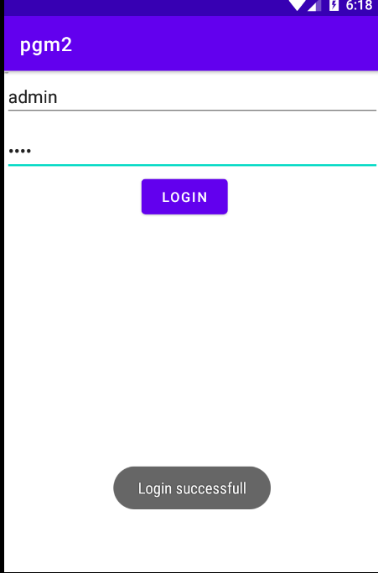

**Program No: 03 Date:23-08-2022**

**Aim**: Write a program to demonstrate the activity life cycle.

**Program Code:**

**activity.xml**

*<?*xml version="1.0" encoding="utf-8"*?>*<androidx.constraintlayout.widget.ConstraintLayout xmlns:android="http://schemas.android.com/apk/res/android"  
 xmlns:app="http://schemas.android.com/apk/res-auto"  
 xmlns:tools="http://schemas.android.com/tools"  
 android:layout_width="match_parent"  
 android:layout_height="match_parent"  
 tools:context=".MainActivity">  
  
 <TextView  
 android:layout_width="wrap_content"  
 android:layout_height="wrap_content"  
 android:text="Hello World!"  
 app:layout_constraintBottom_toBottomOf="parent"  
 app:layout_constraintLeft_toLeftOf="parent"  
 app:layout_constraintRight_toRightOf="parent"  
 app:layout_constraintTop_toTopOf="parent" />

**Mainactivity.java**

package com.example.myapplication;  
  
import androidx.appcompat.app.AppCompatActivity;  
  
import android.os.Bundle;  
import android.util.Log;  
  
public class MainActivity extends AppCompatActivity {  
  
 @Override  
 protected void onCreate(Bundle savedInstanceState) {  
 super.onCreate(savedInstanceState);  
 setContentView(R.layout.*activity_main*);  
 Log.*d*("lifecycle","onCreate invoked");  
 }  
 @Override  
 protected void onStart() {  
 super.onStart();  
 Log.*d*("lifecycle","onStart invoked");  
 }  
 @Override  
 protected void onResume() {  
 super.onResume();  
 Log.*d*("lifecycle","onResume invoked");  
 }  
 @Override  
 protected void onPause() {  
 super.onPause();  
 Log.*d*("lifecycle","onPause invoked");  
 }  
 @Override  
 protected void onStop() {  
 super.onStop();  
 Log.*d*("lifecycle","onStop invoked");  
 }  
 @Override  
 protected void onRestart() {  
 super.onRestart();  
 Log.*d*("lifecycle","onRestart invoked");  
 }  
 @Override  
 protected void onDestroy() {  
 super.onDestroy();  
 Log.*d*("lifecycle","onDestroy invoked");  
 }  
}

**Output**

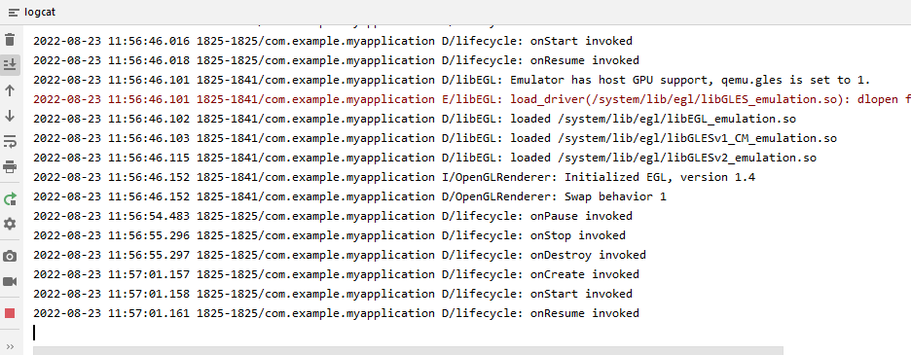

**Program No: 04 Date:14-09-2022**

**Aim**:Implementing basic arithmetic operation of a simple calculator.

**Program Code:**

**activity.xml**

*<?*xml version="1.0" encoding="utf-8"*?>*<LinearLayout  
 xmlns:android="http://schemas.android.com/apk/res/android"  
 xmlns:app="http://schemas.android.com/apk/res-auto"  
 xmlns:tools="http://schemas.android.com/tools"  
 android:layout_width="match_parent"  
 android:layout_height="match_parent"  
 tools:context=".MainActivity"  
 android:orientation="vertical">  
  
 <TextView  
 android:layout_width="wrap_content"  
 android:layout_height="wrap_content"  
 android:text="Simple calculator"/>  
 <TextView  
 android:layout_width="match_parent"  
 android:layout_height="wrap_content"  
 android:text="Enter 1st number"/>  
 <EditText  
 android:layout_width="wrap_content"  
 android:layout_height="wrap_content"  
 android:hint="Enter 1st number"  
 android:id="@+id/n1"/>  
 <TextView  
 android:layout_width="match_parent"  
 android:layout_height="wrap_content"  
 android:text="Enter the 2nd number"/>  
 <EditText  
 android:layout_width="wrap_content"  
 android:layout_height="wrap_content"  
 android:hint="Enter the 2nd number"  
 android:id="@+id/n2"/>  
 <TextView  
 android:layout_width="wrap_content"  
 android:layout_height="wrap_content"  
 android:id="@+id/t1"/>  
 <LinearLayout  
 android:layout_width="wrap_content"  
 android:layout_height="wrap_content">  
 <Button  
 android:layout_width="wrap_content"  
 android:layout_height="wrap_content"  
 android:text="Add"  
 android:id="@+id/b1"/>  
 <Button  
 android:layout_width="wrap_content"  
 android:layout_height="wrap_content"  
 android:text="Sub"  
 android:id="@+id/b2"/>  
 <Button  
 android:layout_width="wrap_content"  
 android:layout_height="wrap_content"  
 android:text="Mul"  
 android:id="@+id/b3"/>  
 <Button  
 android:layout_width="wrap_content"  
 android:layout_height="wrap_content"  
 android:text="Div"  
 android:id="@+id/b4"/>  
 </LinearLayout>  
  
</LinearLayout>

**Mainactivity.java**

package com.example.myapplication4;  
  
import androidx.appcompat.app.AppCompatActivity;  
  
import android.os.Bundle;  
import android.view.View;  
import android.widget.Button;  
import android.widget.EditText;  
import android.widget.TextView;  
  
public class MainActivity extends AppCompatActivity {  
  
 @Override  
 protected void onCreate(Bundle savedInstanceState) {  
 super.onCreate(savedInstanceState);  
 setContentView(R.layout.*activity_main*);  
 EditText t1=findViewById(R.id.*n1*);  
 EditText t2=findViewById(R.id.*n2*);  
 Button add=findViewById(R.id.*b1*);  
 Button sub=findViewById(R.id.*b2*);  
 Button mul=findViewById(R.id.*b3*);  
 Button div=findViewById(R.id.*b4*);  
 TextView tv1=findViewById(R.id.*t1*);  
 add.setOnClickListener(new View.OnClickListener() {  
 @Override  
 public void onClick(View view) {  
 Double a1 = Double.*parseDouble*(t1.getText().toString());  
 Double a2 = Double.*parseDouble*(t2.getText().toString());  
 Double r = a1 + a2;  
 tv1.setText("Result is: " + String.*valueOf*(r));  
 }  
 });  
 sub.setOnClickListener(new View.OnClickListener() {  
 @Override  
 public void onClick(View view) {  
 Double s1=Double.*parseDouble*(t1.getText().toString());  
 Double s2=Double.*parseDouble*(t2.getText().toString());  
 Double r=s1-s2;  
 tv1.setText("Result is: "+String.*valueOf*(r));  
 }  
 });  
 mul.setOnClickListener(new View.OnClickListener() {  
 @Override  
 public void onClick(View view) {  
 Double m1 = Double.*parseDouble*(t1.getText().toString());  
 Double m2 = Double.*parseDouble*(t2.getText().toString());  
 Double r = m1 * m2;  
 tv1.setText("Result is" + String.*valueOf*(r));  
  
 }  
 });  
 div.setOnClickListener(new View.OnClickListener() {  
 @Override  
 public void onClick(View view) {  
 Double d1=Double.*parseDouble*(t1.getText().toString());  
 Double d2=Double.*parseDouble*(t2.getText().toString());  
 Double r=d1/d2;  
 tv1.setText("Result is" +String.*valueOf*(r));  
 }  
 });  
  
  
 }  
  
}

**Output**

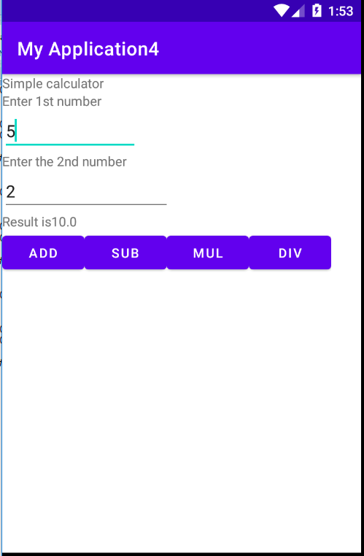

**Program No: 05 Date:20-09-2022**

**Aim**:Implement validation on various UI controls.

**Program Code:**

**activity.xml**

*<?*xml version="1.0" encoding="utf-8"*?>*<LinearLayout xmlns:android="http://schemas.android.com/apk/res/android"  
 xmlns:app="http://schemas.android.com/apk/res-auto"  
 xmlns:tools="http://schemas.android.com/tools"  
 android:layout_width="match_parent"  
 android:layout_height="match_parent"  
 android:orientation="vertical"  
 tools:context=".MainActivity">  
  
 <TextView  
 android:layout_width="match_parent"  
 android:layout_height="wrap_content"  
 android:text="REGISTRATION"  
 android:textColor="@color/design_default_color_error"  
 android:textSize="30dp"/>  
 <EditText  
 android:layout_width="match_parent"  
 android:layout_height="wrap_content"  
 android:hint="NAME"  
 android:id="@+id/name"/>  
 <EditText  
 android:layout_width="match_parent"  
 android:layout_height="wrap_content"  
 android:hint="MOBILE NUMBER"  
 android:id="@+id/mobile"/>  
 <EditText  
 android:layout_width="match_parent"  
 android:layout_height="wrap_content"  
 android:hint="AGE"  
 android:id="@+id/age"/>  
 <TextView  
 android:layout_width="wrap_content"  
 android:layout_height="wrap_content"  
 android:text="GENDER"  
 android:textSize="20dp"  
 android:textColor="@color/design_default_color_primary"/>  
 <RadioGroup  
 android:layout_width="wrap_content"  
 android:layout_height="wrap_content"  
 android:id="@+id/RG">  
 <RadioButton  
 android:layout_width="wrap_content"  
 android:layout_height="wrap_content"  
 android:id="@+id/radiobutton1"  
 android:text="Male"/>  
 <RadioButton  
 android:layout_width="wrap_content"  
 android:layout_height="wrap_content"  
 android:id="@+id/radiobutton2"  
 android:text="Female"/>  
 </RadioGroup>  
 <Button  
 android:layout_width="wrap_content"  
 android:layout_height="wrap_content"  
 android:text="Submit"  
 android:id="@+id/button"/>  
 <CheckBox  
 android:layout_width="wrap_content"  
 android:layout_height="wrap_content"  
 android:text="i agree all terms and conditions"  
 android:id="@+id/checkbox"/>

</LinearLayout

**Mainactivity.java**

package com.example.myapplication5;  
  
import androidx.appcompat.app.AppCompatActivity;  
  
import android.content.Intent;  
import android.os.Bundle;  
import android.view.View;  
import android.widget.Button;  
import android.widget.CheckBox;  
import android.widget.EditText;  
import android.widget.RadioButton;  
import android.widget.RadioGroup;  
import android.widget.Toast;  
  
public class MainActivity extends AppCompatActivity {  
 EditText name;  
 EditText mobileno;  
 EditText age;  
 RadioGroup radiogroup;  
 RadioButton male;  
 RadioButton female;  
 CheckBox checkbox;  
 Button button;  
  
 @Override  
 protected void onCreate(Bundle savedInstanceState) {  
 super.onCreate(savedInstanceState);  
 setContentView(R.layout.*activity_main*);  
 name=findViewById(R.id.*name*);  
 mobileno=findViewById(R.id.*mobile*);  
 age=findViewById(R.id.*age*);  
 radiogroup=findViewById(R.id.*RG*);  
 male=findViewById(R.id.*radiobutton1*);  
 female=findViewById(R.id.*radiobutton2*);  
 checkbox=findViewById(R.id.*checkbox*);  
 button=findViewById(R.id.*button*);  
 button.setOnClickListener(new View.OnClickListener() {  
 @Override  
 public void onClick(View view) {  
 if (error()){  
 Intent i=new Intent(MainActivity.this,login.class);  
 startActivity(i);  
 }  
 }  
 });  
 }  
 private boolean error(){  
 if (name.getText().toString().length()==0){  
 Toast.*makeText*(getApplicationContext(),"Please enter the name",Toast.*LENGTH_LONG*).show();  
 return false;  
 }else if (mobileno.getText().toString().length()==0){  
 Toast.*makeText*(getApplicationContext(),"please enter mobile number",Toast.*LENGTH_LONG*).show();  
 return false;  
 }  
 else if (mobileno.getText().toString().length()!=10){  
 Toast.*makeText*(getApplicationContext(),"please enter 10 numbers",Toast.*LENGTH_LONG*).show();  
 return false;  
 }  
 else if (!male.isChecked() && !female.isChecked()){  
 Toast.*makeText*(getApplicationContext(),"please choose radio button",Toast.*LENGTH_LONG*).show();  
 return false;  
 }else if (!checkbox.isChecked()){  
 Toast.*makeText*(getApplicationContext(),"Please click on checkbox",Toast.*LENGTH_LONG*).show();  
 return false;  
 }else {  
 return true;  
 }  
 }

}

**activity_login.xml**

*<?*xml version="1.0" encoding="utf-8"*?>*<LinearLayout xmlns:android="http://schemas.android.com/apk/res/android"  
 xmlns:app="http://schemas.android.com/apk/res-auto"  
 xmlns:tools="http://schemas.android.com/tools"  
 android:layout_width="match_parent"  
 android:layout_height="match_parent"  
 tools:context=".login">  
  
 <TextView  
 android:id="@+id/textView"  
 android:layout_width="wrap_content"  
 android:layout_height="wrap_content"  
 android:text="Welcome to my login page"  
 tools:layout_editor_absoluteX="121dp"  
 tools:layout_editor_absoluteY="194dp" />  
</LinearLayout>

**Login.java**

package com.example.myapplication5;  
  
import androidx.appcompat.app.AppCompatActivity;  
  
import android.os.Bundle;  
  
public class login extends AppCompatActivity {  
  
 @Override  
 protected void onCreate(Bundle savedInstanceState) {  
 super.onCreate(savedInstanceState);  
 setContentView(R.layout.*activity_login*);  
 }

}

**Output**

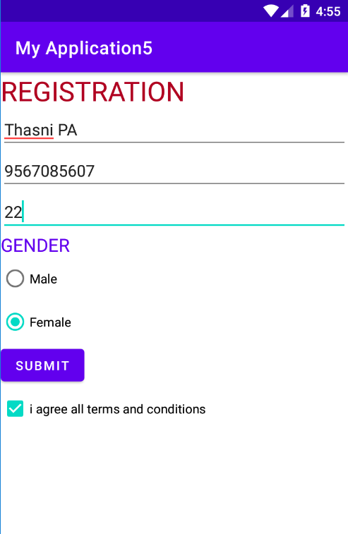

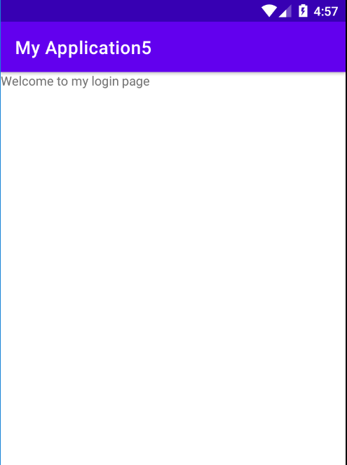

**Program No: 06 Date:20-09-2022**

**Aim**:Design a registration activity and store registration details in local memory of phone using intent and shared preferences

**Program Code:**

**activity.xml**

*<?*xml version="1.0" encoding="utf-8"*?>*<RelativeLayout xmlns:android="http://schemas.android.com/apk/res/android"  
 xmlns:app="http://schemas.android.com/apk/res-auto"  
 xmlns:tools="http://schemas.android.com/tools"  
 android:layout_width="match_parent"  
 android:layout_height="match_parent"  
 tools:context=".MainActivity"  
 tools:ignore="HardcodedText">  
  
 <TextView  
 android:id="@+id/textview"  
 android:layout_width="wrap_content"  
 android:layout_height="wrap_content"  
 android:layout_centerHorizontal="true"  
 android:layout_marginTop="32dp"  
 android:text="Registration form"  
 android:textColor="@android:color/black"  
 android:textSize="24sp"/>  
 <EditText  
 android:id="@+id/edit1"  
 android:layout_width="match_parent"  
 android:layout_height="wrap_content"  
 android:layout_below="@+id/textview"  
 android:layout_marginStart="16dp"  
 android:layout_marginTop="8dp"  
 android:layout_marginEnd="16dp"  
 android:hint="Enter your name"  
 android:padding="10dp"/>  
 <EditText  
 android:id="@+id/edit2"  
 android:layout_width="match_parent"  
 android:layout_height="wrap_content"  
 android:layout_below="@+id/edit1"  
 android:layout_marginStart="16dp"  
 android:layout_marginTop="8dp"  
 android:layout_marginEnd="16dp"  
 android:hint="Enter your age"  
 android:padding="10dp"  
 android:inputType="number"/>  
 <EditText  
 android:id="@+id/edit3"  
 android:layout_width="match_parent"  
 android:layout_height="wrap_content"  
 android:layout_below="@+id/edit2"  
 android:layout_marginStart="16dp"  
 android:layout_marginTop="8dp"  
 android:layout_marginEnd="16dp"  
 android:hint="Enter your Email id"  
 android:padding="10dp"/>  
 <EditText  
 android:id="@+id/edit4"  
 android:layout_width="match_parent"  
 android:layout_height="wrap_content"  
 android:layout_below="@+id/edit3"  
 android:layout_marginStart="16dp"  
 android:layout_marginTop="8dp"  
 android:layout_marginEnd="16dp"  
 android:hint="Enter your Address"  
 android:padding="10dp"/>  
 <EditText  
 android:id="@+id/edit5"  
 android:layout_width="match_parent"  
 android:layout_height="wrap_content"  
 android:layout_below="@+id/edit4"  
 android:layout_marginStart="16dp"  
 android:layout_marginTop="8dp"  
 android:layout_marginEnd="16dp"  
 android:hint="Enter your gender"  
 android:padding="10dp"/>  
 <EditText  
 android:id="@+id/edit6"  
 android:layout_width="match_parent"  
 android:layout_height="wrap_content"  
 android:layout_below="@+id/edit5"  
 android:layout_marginStart="16dp"  
 android:layout_marginTop="8dp"  
 android:layout_marginEnd="16dp"  
 android:hint="Enter your Qualification"  
 android:padding="10dp"/>  
 <Button  
 android:layout_width="wrap_content"  
 android:layout_height="wrap_content"  
 android:id="@+id/b1"  
 android:layout_below="@+id/edit6"  
 android:text="Submit"/>  
</RelativeLayout>

**MainActivity.java**

package com.example.myapplication6;  
  
import androidx.appcompat.app.AppCompatActivity;  
  
import android.content.Intent;  
import android.content.SharedPreferences;  
import android.os.Bundle;  
import android.view.View;  
import android.widget.Button;  
import android.widget.EditText;  
  
public class MainActivity extends AppCompatActivity {  
 private EditText name,age,email,address,gender,quali;  
 Button b1;  
  
 @Override  
 protected void onCreate(Bundle savedInstanceState) {  
 super.onCreate(savedInstanceState);  
 setContentView(R.layout.*activity_main*);  
 name=findViewById(R.id.*edit1*);  
 age=findViewById(R.id.*edit2*);  
 email=findViewById(R.id.*edit3*);  
 address=findViewById(R.id.*edit4*);  
 gender=findViewById(R.id.*edit5*);  
 quali=findViewById(R.id.*edit6*);  
 b1=findViewById(R.id.*b1*);  
 b1.setOnClickListener(new View.OnClickListener() {  
 @Override  
 public void onClick(View view) {  
 Intent i=new Intent(MainActivity.this,MainActivity2.class);  
 startActivity(i);  
 }  
 });  
 }  
 protected void onResume() {  
 super.onResume();  
 SharedPreferences sh = getSharedPreferences("mysharedpref", *MODE_PRIVATE*);  
 String s1 = sh.getString("name", "");  
 int a = sh.getInt("age", 0);  
 String s2 = sh.getString("email", "");  
 String s3 = sh.getString("address", "");  
 String s4 = sh.getString("gender", "");  
 String s5 = sh.getString("quali", "");  
 name.setText(s1);  
 age.setText(String.*valueOf*(a));  
 email.setText(s2);  
 address.setText(s3);  
 gender.setText(s4);  
 quali.setText(s5);  
 }  
 protected void onPause() {  
 super.onPause();  
 SharedPreferences sharedPreferences = getSharedPreferences("mysharedpref", *MODE_PRIVATE*);  
 SharedPreferences.Editor myEdit = sharedPreferences.edit();  
 myEdit.putString("name", name.getText().toString());  
 myEdit.putInt("age", Integer.*parseInt*(age.getText().toString()));  
 myEdit.putString("email", email.getText().toString());  
 myEdit.putString("address", address.getText().toString());  
 myEdit.putString("gender", gender.getText().toString());  
 myEdit.putString("quali", quali.getText().toString());  
 myEdit.commit();  
 }  
  
  
}

**activity_main2.xml**

*<?*xml version="1.0" encoding="utf-8"*?>*<RelativeLayout xmlns:android="http://schemas.android.com/apk/res/android"  
 xmlns:app="http://schemas.android.com/apk/res-auto"  
 xmlns:tools="http://schemas.android.com/tools"  
 android:layout_width="match_parent"  
 android:layout_height="match_parent"  
 tools:context=".MainActivity2">  
 <TextView  
 android:layout_width="wrap_content"  
 android:layout_height="wrap_content"  
 android:text="Welocome"/>  
</RelativeLayout>

**MainActivity2.java**

package com.example.myapplication6;  
  
import androidx.appcompat.app.AppCompatActivity;  
  
import android.os.Bundle;  
  
public class MainActivity2 extends AppCompatActivity {  
  
 @Override  
 protected void onCreate(Bundle savedInstanceState) {  
 super.onCreate(savedInstanceState);  
 setContentView(R.layout.*activity_main2*);  
 }

}

**OUTPUT**

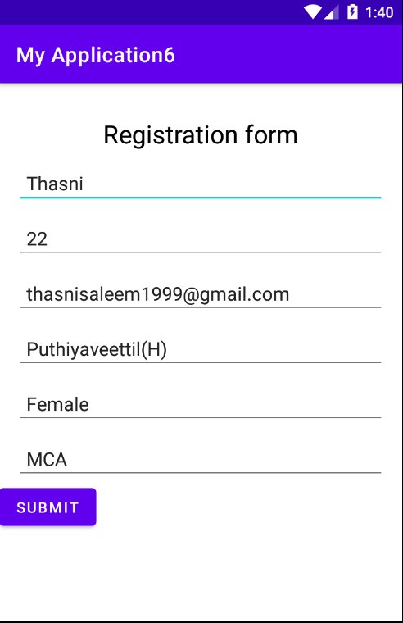

**Program No: 07 Date:20-09-2022**

**Aim**:Web application to implement implicit intent

**Program Code:**

**activity.xml**

*<?*xml version="1.0" encoding="utf-8"*?>*<LinearLayout xmlns:android="http://schemas.android.com/apk/res/android"  
 xmlns:app="http://schemas.android.com/apk/res-auto"  
 xmlns:tools="http://schemas.android.com/tools"  
 android:layout_width="match_parent"  
 android:layout_height="match_parent"  
 tools:context=".MainActivity">  
  
 <EditText  
 android:id="@+id/t1"  
 android:layout_width="wrap_content"  
 android:layout_height="wrap_content"  
 android:text="http://www.google.co.in"  
 android:textColor="@color/design_default_color_secondary"/>  
 <Button  
 android:id="@+id/btn1"  
 android:layout_width="wrap_content"  
 android:layout_height="wrap_content"  
 android:text="click"  
 android:textColor="@color/design_default_color_error"/>  
  
</LinearLayout>

ManActivity.java

package com.example.myapplication7;  
  
import androidx.appcompat.app.AppCompatActivity;  
  
import android.content.Intent;  
import android.net.Uri;  
import android.os.Bundle;  
import android.view.View;  
import android.widget.Button;  
import android.widget.EditText;  
  
public class MainActivity extends AppCompatActivity {  
 EditText et1;  
 Button b1;  
  
 @Override  
 protected void onCreate(Bundle savedInstanceState) {  
 super.onCreate(savedInstanceState);  
 setContentView(R.layout.*activity_main*);  
 et1=findViewById(R.id.*t1*);  
 b1=findViewById(R.id.*btn1*);  
 b1.setOnClickListener(new View.OnClickListener() {  
 @Override  
 public void onClick(View view) {  
 String url=et1.getText().toString();  
 Intent i=new Intent(Intent.*ACTION_VIEW*, Uri.*parse*(url));  
 startActivity(i);  
 }  
 });  
 }  
}

**OUTPUT**

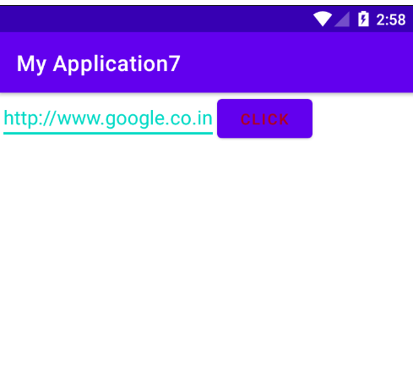

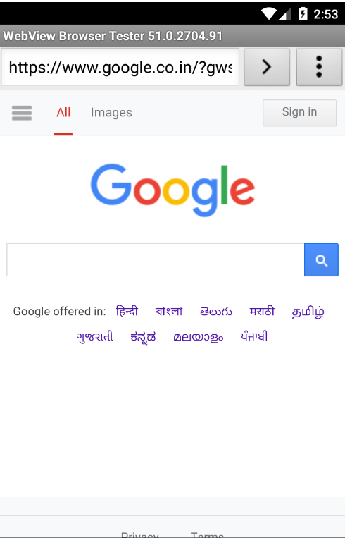

**Program No: 08 Date:25-09-2022**

**Aim**:Implement options menu to navigate two activities.

**Program Code:**

**Activity_main.xml**

*<?*xml version="1.0" encoding="utf-8"*?>*<androidx.constraintlayout.widget.ConstraintLayout xmlns:android="http://schemas.android.com/apk/res/android"  
 xmlns:app="http://schemas.android.com/apk/res-auto"  
 xmlns:tools="http://schemas.android.com/tools"  
 android:layout_width="match_parent"  
 android:layout_height="match_parent"  
 tools:context=".MainActivity">  
  
 <TextView  
 android:layout_width="wrap_content"  
 android:layout_height="wrap_content"  
 android:text="Hello World!"  
 app:layout_constraintBottom_toBottomOf="parent"  
 app:layout_constraintLeft_toLeftOf="parent"  
 app:layout_constraintRight_toRightOf="parent"  
 app:layout_constraintTop_toTopOf="parent" />

</androidx.constraintlayout.widget.ConstraintLayout>

**menu.xml**

*<?*xml version="1.0" encoding="utf-8"*?>*<menu xmlns:android="http://schemas.android.com/apk/res/android">  
 <item android:id="@+id/item1"  
 android:title="File"/>  
 <item android:id="@+id/item2"  
 android:title="Edit">  
 <menu>  
 <item android:id="@+id/sitem1"  
 android:title="Cut"/>  
 <item android:id="@+id/sitem2"  
 android:title="Copy"/>  
 <item android:id="@+id/sitem3"  
 android:title="Paste"/>  
 </menu>  
 </item>  
 <item android:id="@+id/item3"  
 android:title="View"/>

</menu>

**MainActivity.java**

package com.example.myapplication7;  
  
import androidx.annotation.NonNull;  
import androidx.appcompat.app.AppCompatActivity;  
  
import android.os.Bundle;  
import android.view.Menu;  
import android.view.MenuItem;  
import android.widget.Toast;  
  
public class MainActivity extends AppCompatActivity {  
  
 @Override  
 protected void onCreate(Bundle savedInstanceState) {  
 super.onCreate(savedInstanceState);  
 setContentView(R.layout.*activity_main*);  
 }  
  
 @Override  
 public boolean onCreateOptionsMenu(Menu menu) {  
 getMenuInflater().inflate(R.menu.*menu*,menu);  
 return true;  
 }  
  
 @Override  
 public boolean onOptionsItemSelected(@NonNull MenuItem item) {  
 switch (item.getItemId()){  
 case R.id.*item1*:  
 Toast.*makeText*(getApplicationContext(),"File selected",Toast.*LENGTH_SHORT*).show();  
 break;  
 case R.id.*item2*:  
 Toast.*makeText*(getApplicationContext(),"Edit selected",Toast.*LENGTH_SHORT*).show();  
 break;  
 case R.id.*sitem1*:  
 Toast.*makeText*(getApplicationContext(),"Cut selected",Toast.*LENGTH_SHORT*).show();  
 break;  
 case R.id.*sitem2*:  
 Toast.*makeText*(getApplicationContext(),"Copy selected",Toast.*LENGTH_SHORT*).show();  
 break;  
 case R.id.*sitem3*:  
 Toast.*makeText*(getApplicationContext(),"Paste selected",Toast.*LENGTH_SHORT*).show();  
 break;  
 case R.id.*item3*:  
 Toast.*makeText*(getApplicationContext(),"View selected",Toast.*LENGTH_SHORT*).show();  
 break;  
  
 }  
 return super.onOptionsItemSelected(item);  
 }

}

**OUTPUT**

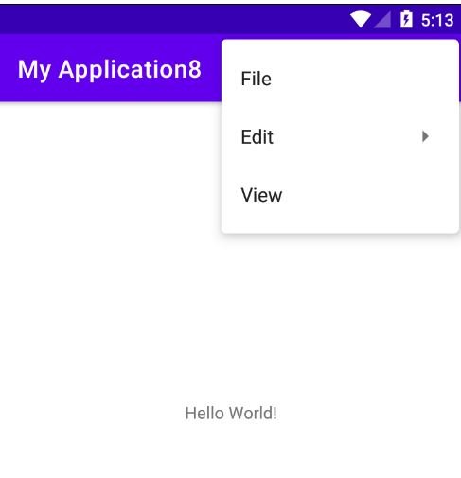

**Program No: 09 Date:28-09-2022**

**Aim**:Design a simple calculator using GridLayout.

**Program Code:**

**Activity_main.xml**

*<?*xml version="1.0" encoding="utf-8"*?>*<GridLayout xmlns:android="http://schemas.android.com/apk/res/android"  
 xmlns:app="http://schemas.android.com/apk/res-auto"  
 xmlns:tools="http://schemas.android.com/tools"  
 android:layout_width="match_parent"  
 android:layout_height="match_parent"  
 tools:context=".MainActivity">  
  
 <TextView  
 android:layout_width="wrap_content"  
 android:layout_height="wrap_content"  
 android:text="Enter 1st num"  
 android:layout_row="0"  
 android:layout_column="0"/>  
 <EditText  
 android:layout_width="wrap_content"  
 android:layout_height="wrap_content"  
 android:id="@+id/n1"  
 android:layout_row="1"  
 android:layout_column="0"/>  
 <TextView  
 android:layout_width="wrap_content"  
 android:layout_height="wrap_content"  
 android:text="Enter 1st num"  
 android:layout_row="2"  
 android:layout_column="0"/>  
 <EditText  
 android:layout_width="wrap_content"  
 android:layout_height="wrap_content"  
 android:id="@+id/n2"  
 android:layout_row="3"  
 android:layout_column="0"/>  
 <Button  
 android:text="ADD"  
 android:layout_width="wrap_content"  
 android:layout_height="wrap_content"  
 android:layout_row="4"  
 android:layout_column="2"  
 android:textColor="@color/white"  
 android:background="@color/design_default_color_error"  
 android:id="@+id/add"/>  
 <Button  
 android:text="MUL"  
 android:layout_width="wrap_content"  
 android:layout_height="wrap_content"  
 android:layout_row="4"  
 android:layout_column="1"  
 android:textColor="@color/white"  
 android:background="@color/design_default_color_error"  
 android:id="@+id/mul"/>  
 <Button  
 android:text="SUB"  
 android:layout_width="wrap_content"  
 android:layout_height="wrap_content"  
 android:layout_row="4"  
 android:layout_column="0"  
 android:textColor="@color/white"  
 android:background="@color/design_default_color_error"  
 android:id="@+id/sub"/>  
 <Button  
 android:text="DIV"  
 android:layout_width="wrap_content"  
 android:layout_height="wrap_content"  
 android:layout_row="4"  
 android:layout_column="3"  
 android:textColor="@color/white"  
 android:background="@color/design_default_color_error"  
 android:id="@+id/div"/>  
  
 <TextView  
 android:hint="Result"  
 android:width="70dp"  
 android:height="50dp"  
 android:layout_row="2"  
 android:layout_column="2"  
 android:id="@+id/result"  
 android:textColor="@color/design_default_color_error"/>  
</GridLayout>

**MainActivity.java**

package com.example.myapplication9;  
  
import androidx.appcompat.app.AppCompatActivity;  
  
import android.os.Bundle;  
import android.view.View;  
import android.widget.Button;  
import android.widget.EditText;  
import android.widget.TextView;  
  
public class MainActivity extends AppCompatActivity {  
  
 @Override  
 protected void onCreate(Bundle savedInstanceState) {  
 super.onCreate(savedInstanceState);  
 setContentView(R.layout.*activity_main*);  
  
  
 EditText a = findViewById(R.id.*n1*);  
 EditText b = findViewById(R.id.*n2*);  
  
  
 Button add = findViewById(R.id.*add*);  
 Button mul = findViewById(R.id.*mul*);  
 Button sub = findViewById(R.id.*sub*);  
 Button div = findViewById(R.id.*div*);  
 TextView result = findViewById(R.id.*result*);  
 add.setOnClickListener(new View.OnClickListener() {  
 @Override  
 public void onClick(View view) {  
 Double n1 = Double.*parseDouble*(a.getText().toString());  
 Double n2 = Double.*parseDouble*(b.getText().toString());  
 Double r = n1 + n2;  
 result.setText(String.*valueOf*(r));  
 }  
 });  
 sub.setOnClickListener(new View.OnClickListener() {  
 @Override  
 public void onClick(View view) {  
 Double n1 = Double.*parseDouble*(a.getText().toString());  
 Double n2 = Double.*parseDouble*(b.getText().toString());  
 Double r = n1 - n2;  
 result.setText(String.*valueOf*(r));  
 }  
 });  
 mul.setOnClickListener(new View.OnClickListener() {  
 @Override  
 public void onClick(View view) {  
 Double n1 = Double.*parseDouble*(a.getText().toString());  
 Double n2 = Double.*parseDouble*(b.getText().toString());  
 Double r = n1 * n2;  
 result.setText(String.*valueOf*(r));  
 }  
 });  
 div.setOnClickListener(new View.OnClickListener() {  
 @Override  
 public void onClick(View view) {  
 Double n1 = Double.*parseDouble*(a.getText().toString());  
 Double n2 = Double.*parseDouble*(b.getText().toString());  
 Double r = n1 / n2;  
 result.setText(String.*valueOf*(r));  
 }  
 });  
  
 }

}

**OUTPUT**

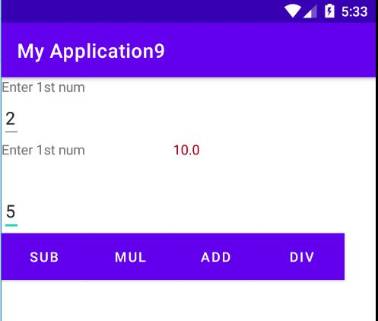

**Program No:10 Date:31-09-2022**

**Aim**:Develop an application that uses ArrayAdapter with ListView.

**Program Code:**

**Activity_main.xml**

*<?*xml version="1.0" encoding="utf-8"*?>*<LinearLayout xmlns:android="http://schemas.android.com/apk/res/android"  
 xmlns:app="http://schemas.android.com/apk/res-auto"  
 xmlns:tools="http://schemas.android.com/tools"  
 android:layout_width="match_parent"  
 android:layout_height="match_parent"  
 app:layout_behavior="@string/appbar_scrolling_view_behavior"  
 tools:context=".MainActivity"  
 tools:showIn="@layout/activity_main">  
  
 <ListView  
 android:layout_width="match_parent"  
 android:layout_height="match_parent"  
 android:id="@+id/l"/>

</LinearLayout>

**MainActivity.java**

package com.example.myapplication10;  
  
import androidx.appcompat.app.AppCompatActivity;  
  
import android.content.Intent;  
import android.os.Bundle;  
import android.view.View;  
import android.widget.AdapterView;  
import android.widget.ArrayAdapter;  
import android.widget.ListView;  
  
public class MainActivity extends AppCompatActivity {  
 ListView l;  
 String[] p={"A.P.J Abdul Kalam","Sachin Tendulkar"," Cristiano Ronaldo"};  
  
 @Override  
 protected void onCreate(Bundle savedInstanceState) {  
 super.onCreate(savedInstanceState);  
 setContentView(R.layout.*activity_main*);  
 l=findViewById(R.id.*l*);  
 ArrayAdapter <String>adapter=new ArrayAdapter<String>(this, android.R.layout.*simple_list_item_1*,p);  
 l.setAdapter(adapter);  
 l.setOnItemClickListener(new AdapterView.OnItemClickListener() {  
 @Override  
 public void onItemClick(AdapterView<?> adapterView, View view, int i, long l) {  
 if(i==0)  
 {  
 Intent s=new Intent(MainActivity.this,MainActivity2.class);  
 startActivity(s);  
 }  
 else if (i==1)  
 {  
 Intent s=new Intent(MainActivity.this,MainActivity3.class);  
 startActivity(s);  
 }  
 else if (i==2)  
 {  
 Intent s=new Intent(MainActivity.this,MainActivity4.class);  
 startActivity(s);  
  
 }  
  
 }  
 });  
 }

}

**Activity_main2.xml**

*<?*xml version="1.0" encoding="utf-8"*?>*<androidx.constraintlayout.widget.ConstraintLayout xmlns:android="http://schemas.android.com/apk/res/android"  
 xmlns:app="http://schemas.android.com/apk/res-auto"  
 xmlns:tools="http://schemas.android.com/tools"  
 android:layout_width="match_parent"  
 android:layout_height="match_parent"  
 tools:context=".MainActivity2">  
<TextView  
 android:layout_width="match_parent"  
 android:layout_height="match_parent"  
 android:text="Born on 15th October 1931 at Rameswaram in Tamil Nadu, Dr.Avul Pakir Jainulabdeen Abdul Kalam specialized in Aeronautical Engineering from Madras Institute of Technology."/>  
</androidx.constraintlayout.widget.ConstraintLayout>

**Activity_main3.xml**

*<?*xml version="1.0" encoding="utf-8"*?>*<androidx.constraintlayout.widget.ConstraintLayout xmlns:android="http://schemas.android.com/apk/res/android"  
 xmlns:app="http://schemas.android.com/apk/res-auto"  
 xmlns:tools="http://schemas.android.com/tools"  
 android:layout_width="match_parent"  
 android:layout_height="match_parent"  
 tools:context=".MainActivity3">  
<TextView  
 android:layout_width="match_parent"  
 android:layout_height="match_parent"  
 android:text="Sachin Tendulkar was the most complete batter of his time, the most prolific run-maker of all time, and arguably the biggest cricket icon the game has ever known."/>  
</androidx.constraintlayout.widget.ConstraintLayout>

**Activity_main4.xml**

*<?*xml version="1.0" encoding="utf-8"*?>*<androidx.constraintlayout.widget.ConstraintLayout xmlns:android="http://schemas.android.com/apk/res/android"  
 xmlns:app="http://schemas.android.com/apk/res-auto"  
 xmlns:tools="http://schemas.android.com/tools"  
 android:layout_width="match_parent"  
 android:layout_height="match_parent"  
 tools:context=".MainActivity4">  
<TextView  
 android:layout_width="match_parent"  
 android:layout_height="match_parent"  
 android:text="In February 2021, Ronaldo became the first person in the world to reach 500 million followers across Facebook, Instagram and Twitter."/>  
</androidx.constraintlayout.widget.ConstraintLayout>

**OUTPUT**

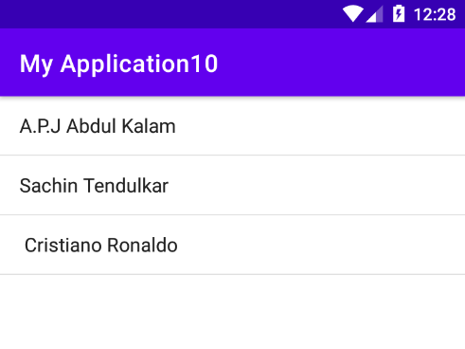

**Program No:11 Date:31-09-2022**

**Aim**:

**Program Code:**

**Activity_main.xml**

*<?*xml version="1.0" encoding="utf-8"*?>*<FrameLayout xmlns:android="http://schemas.android.com/apk/res/android"  
 android:id="@+id/frameLayout"  
 android:layout_width="fill_parent"  
 android:layout_height="fill_parent">  
 <ImageView  
 android:id="@+id/image1"  
 android:layout_width="match_parent"  
 android:layout_height="400dp"  
 android:scaleType="center"  
 android:src="@drawable/sea2"/>  
 <ImageView  
 android:id="@+id/image2"  
 android:layout_width="match_parent"  
 android:layout_height="400dp"  
 android:scaleType="centerCrop"  
 android:src="@drawable/sea3"/>  
  
</FrameLayout>

**MainActivity.java**

package com.example.myapplication11;  
  
import androidx.appcompat.app.AppCompatActivity;  
  
import android.os.Bundle;  
import android.view.View;  
import android.widget.ImageView;  
  
public class MainActivity extends AppCompatActivity {  
 ImageView i1,i2;  
  
 @Override  
 protected void onCreate(Bundle savedInstanceState) {  
 super.onCreate(savedInstanceState);  
 setContentView(R.layout.*activity_main*);  
 i1=findViewById(R.id.*image1*);  
 i2=findViewById(R.id.*image2*);  
 i2.setOnClickListener(new View.OnClickListener() {  
 @Override  
 public void onClick(View view) {  
 i2.setVisibility(view.*GONE*);  
 i1.setVisibility(view.*VISIBLE*);  
 }  
 });  
 i1.setOnClickListener(new View.OnClickListener() {  
 @Override  
 public void onClick(View view) {  
 i1.setVisibility(View.*GONE*);  
 i2.setVisibility(View.*VISIBLE*);  
 }  
 });  
 }  
}

**OUTPUT**



**Program No:12 Date:31-09-2022**

**Aim**:

**Program Code:**

**Activity_main.xml**